Transportation Problems
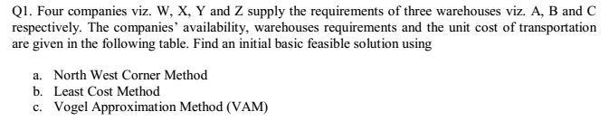
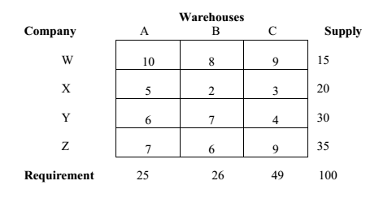

Q2. Find an initial basic feasible solution using
a. North West Corner Method
b. Least Cost Method
c. Vogel Approximation Method (VAM)
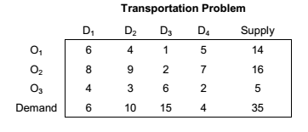
Q3. A company has three production facilities S1, S2 and S3 with production
capacity of 7, 9 and 18 units (in 100s) per week of a product respectively.
These units are to be shipped to four warehouses D1, D2, D3 and D4
with requirement of 5, 8, 7 and 14 units (in 100s) per week, respectively.
Table depicts the transportation costs (in rupees) per unit between
factories to warehouses.
Find an initial basic feasible solution using
a. North West Corner Method
b. Least Cost Method
c. Vogel Approximation Method (VAM)
